This section describes the procedure for debugging the applications using GDB to work with OpenOCD.

# Prerequisites

## Install Talaria TWO SDK

1. Download Talaria TWO SDK from the InnoPhase portal: <https://innophaseiot.com/portal/portal-hub/>
2. Unzip the SDK in an appropriate location as per requirement.

## Required Software

1. PC with Ubuntu 20.04 (or higher).
2. GNU GDB v.10.1 (or higher).

For the above Linux set-up, refer the following user guide: UG_Environment_Setup_for_Linux.pdf.

Execute the following Linux command in any terminal window to determine the versions of Ubuntu and GNU GDB:

For Ubuntu version:

|  |
| --- |
| lsb_release -a |

Console output:

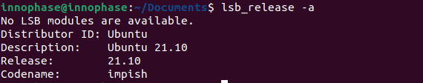

Figure : Ubuntu version

For GNU GDB version:

|  |
| --- |
| gdb --version |

**Note:** In case of Ubuntu 20.04, default version of the GDB is 9.2. Hence, GDB needs to be updated

to version 10.2 by executing the following commands:

|  |
| --- |
| sudo add-apt-repository ppa:ubuntu-toolchain-r/test  sudo apt-get update  sudo apt-get -y --force-yes install gdb |

Console output:

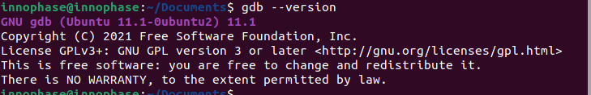

Figure : GNU GDB version

## Installing necessary packages

In any terminal window, execute the following commands:

|  |
| --- |
| sudo apt update  sudo apt install build-essential libc6-armel-cross libc6-dev-armel-cross binutils-arm-linux-gnueabi libncurses5-dev -y |

## Installing ARM toolchain

From within a directory of your choice, execute the following command in a terminal window to download the ARM toolchain:

|  |
| --- |
| sudo apt install gcc-arm-none-eabi |

## Installing Python3 and dependencies

In any terminal window, execute the following commands to install Python3 and other Python packages that will be needed. Enter the password as prompted.

|  |
| --- |
| sudo apt install python3 -y  sudo apt install python3-pip -y  pip3 install pyelftools pyserial pyusb pyftdi ecdsa pycryptodome |

## Installing OpenOCD

In any terminal window, execute the following command to install OpenOCD. Enter the password as prompted.

|  |
| --- |
| sudo apt install openocd -y |

Install gdb-multiarch in any terminal window. Execute the following command to install gdb-multiarch:

|  |
| --- |
| sudo apt-get install gdb-multiarch |

# VM versus Non VM based application

There are two types of application that could be generated based on the virtual memory usage for executing the application on Talaria TWO:

1. **VM based application:**

In case of a VM based application, a portion of the flash memory is allocated to be used as virtual memory. The application stored in Talaria TWO’s FLASH/ROM is loaded into virtual memory for execution by the MCU.

1. **Non-VM based application:**

In case of a Non-VM image, no virtual memory is allocated and the MCU executes the application by directly fetching it from Talaria TWO’s ROM/Flash.

# Procedure to Debug using GDB

Following is the procedure to debug the VM-based applications using GDB:

1. Open the SDK folder in Ubuntu terminal and type the following command to start OpenOCD:

|  |
| --- |
| sudo openocd -s ./conf -f ftdi.cfg -f t2.cfg |

Console output:

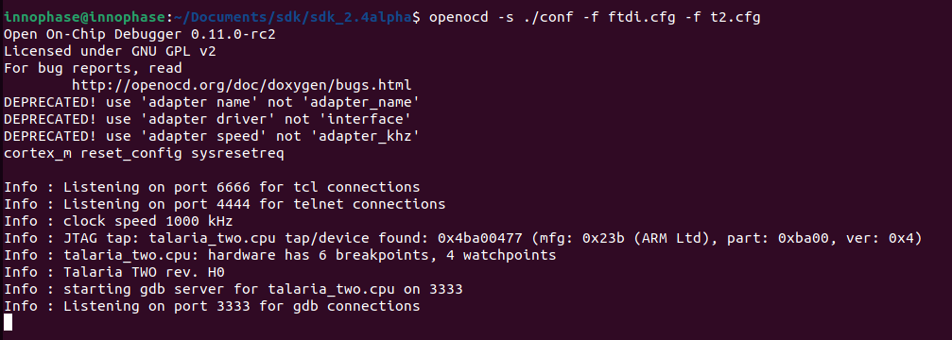

Figure : Starting openOCD

1. In a separate terminal, flash the virtual image from the SDK directory.

For example: Consider wifi_connect.elf.

|  |
| --- |
| ./script/boot.py --reset=evk42_bl --speed=2457600 --gdb examples/using_wifi/out/wifi_connect.elf |

**Note**: For the GDB to work, ELF needs to be loaded. By default, the SDK package contains ELF files in the bin folder (which are stripped ELF files). Hence, user needs to build the sample application, generate the ELF file (by default, it gets generated in the out folder) and load this ELF for debugging.

Execute make for using_wifi example application (sdk_2.4/examples/using_wifi) to generate the ELFs under the out folder.

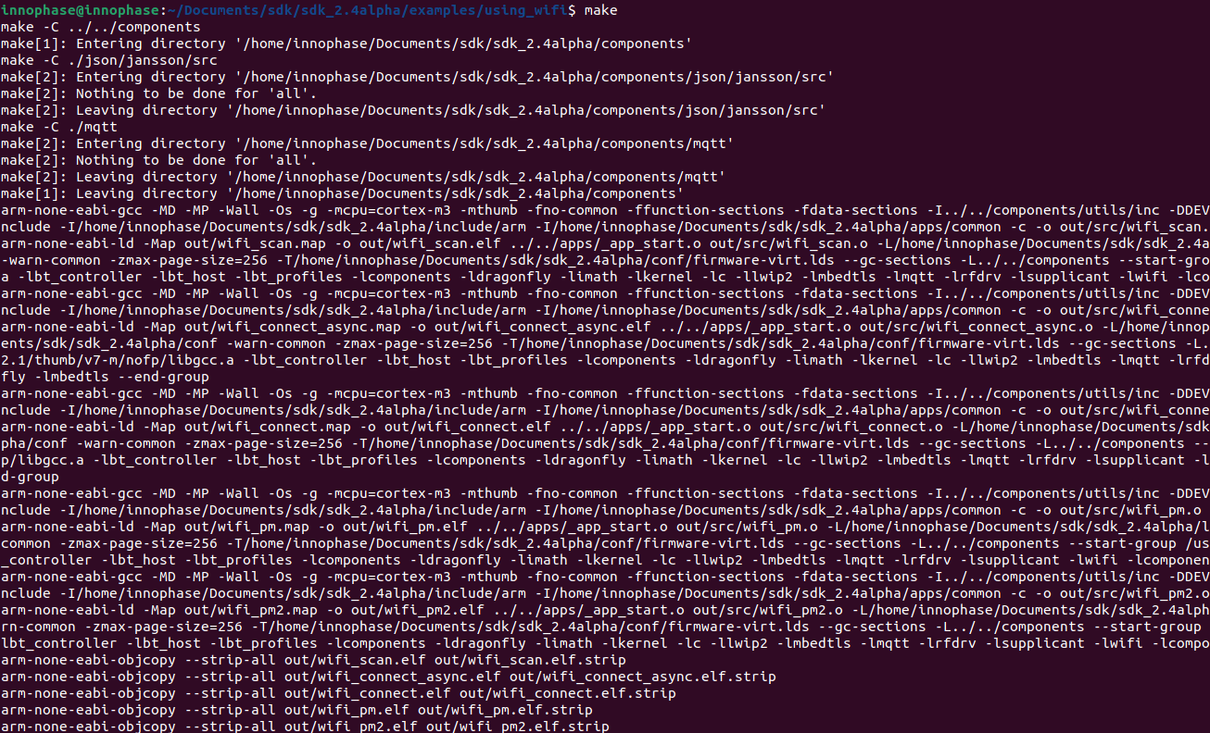

Figure : make command output for using_wifi

Following is the output for a sample application wifi_connect.elf. The total number of bytes displayed in Figure 5 will vary with the ELF of the application being flashed.

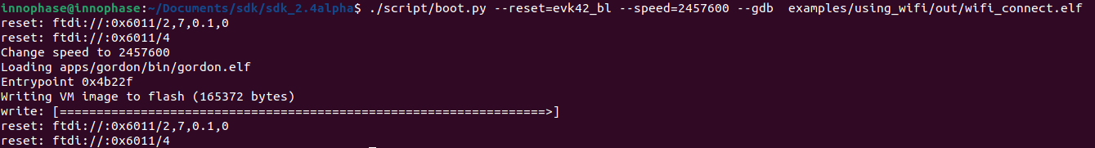

Figure : Flashing the application from SDK directory

.gdbinit initialization file contains the information on Talaria TWO’s memory regions and the required scripts of the GDB sources. gdbinit file is present under the apps folder. To start the GDB session, gdb-multiarch should be started from this folder.

Command line method of configuring the gdbinit file

GDB method relies on the GDB scripts. Initially, GDB needs to be configured to allow auto-load.

|  |
| --- |
| echo "set auto-load safe-path /" > ~/.gdbinit |

Manual method of configuring the gdbinit file:

If there are any warnings as shown in Figure 6, the gdb-multiarch does not work for GDB commands. Hence, create a file named gdbinit in the home directory to allow auto-load.

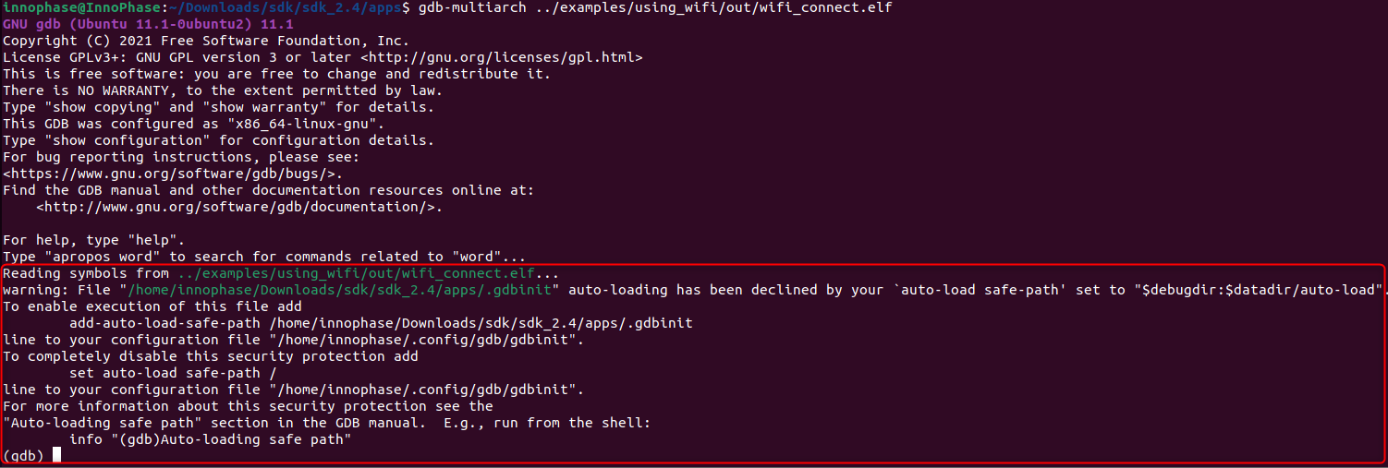

Figure : Warning for .gdbinit file

In the created gdbinit file add the following path:

add-auto-load-safe-path/home/innophase/Downloads/sdk/sdk_2.4/apps/.gdbinit.

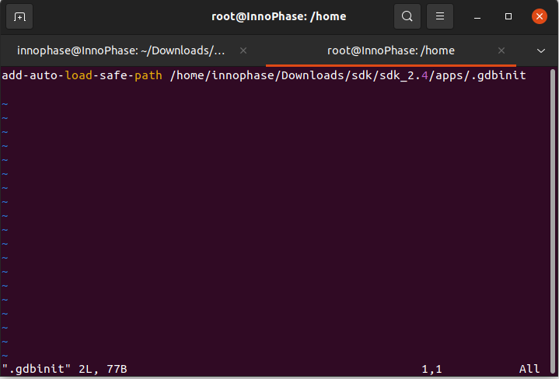

Figure : Configuring the gdbinit file

## Start the GDB Session

In a separate terminal, run the following command from the sdk_x.y/apps directory. In this directory, there is a .gdbinit file that configures the GDB. Here, the RAM portion of the ELF gets loaded.

**Note**: x and y in sdk_x.y refer to the SDK release version.

|  |
| --- |
| gdb-multiarch ../examples/using_wifi/out/wifi_connect.elf |

Console output:

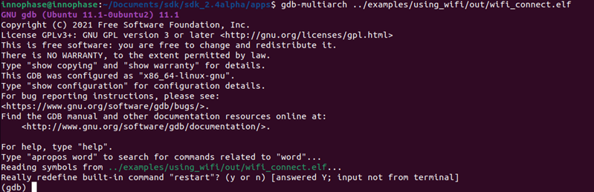

Figure : Running GDB

1. Connect to OpenOCD by running ocd in the GDB prompt.

|  |
| --- |
| ocd |

1. Set a break point at main:

|  |
| --- |
| b main |

1. Run the application by executing:

|  |
| --- |
| R |

1. The information on the break points set can be seen by issuing:

|  |
| --- |
| info b |

1. A break point at a line number of a particular source file can be set using:

|  |
| --- |
| b <filename>: <linenum> |

1. If the line to be executed is a function call, GDB will step into that function and start executing its code one line at a time.

|  |
| --- |
| s |

1. If the entire function needs to be executed with one keypress, type next or n.

|  |
| --- |
| next |

1. Continue running the program (after stopping, for example at a breakpoint).

|  |
| --- |
| continue |

1. Step out is the operation that resumes execution after the function the program is executing terminates. The debugger will stop at the statement after the function call.

|  |
| --- |
| finish |

Example 1: Following is the output while debugging the wifi_connect.elf using GDB:

|  |
| --- |
| (gdb) ocd  0x00023f36 in ?? ()  (gdb) b main  Breakpoint 1 at 0x100020: file wifi_connect/main.c, line 23.  Note: automatically using hardware breakpoints for read-only addresses.  (gdb) R  JTAG tap: talaria_two.cpu tap/device found: 0x4ba00477 (mfg: 0x23b (ARM Ltd), part: 0xba00, ver: 0x4)  target halted due to debug-request, current mode: Thread  xPSR: 0x01000000 pc: 0x00020f90 msp: 0x00041a78  Loading section .text, size 0x1c538 lma 0x42000  Loading section .data, size 0x490 lma 0x5e538  Loading section .virt, size 0x24658 lma 0x2000000  Start address 0x0004ea1e, load size 266272  Transfer rate: 71 KB/sec, 14014 bytes/write.Breakpoint 1, main () at wifi_connect/main.c:23  23 const char *ssid = os_get_boot_arg_str("ssid");  (gdb) info b  Num Type Disp Enb Address What  1 breakpoint keep y 0x00100020 in main at wifi_connect/main.c:23  breakpoint already hit 1 time  (gdb) del 1  (gdb) info b  No breakpoints or watchpoints.  (gdb) b main.c:29  Breakpoint 2 at 0x10003c: file wifi_connect/main.c, line 29.  (gdb) R  JTAG tap: talaria_two.cpu tap/device found: 0x4ba00477 (mfg: 0x23b (ARM Ltd), part: 0xba00, ver: 0x4)  target halted due to debug-request, current mode: Thread  xPSR: 0x01000000 pc: 0x00020f90 msp: 0x00041a78  Loading section .text, size 0x1c538 lma 0x42000  Loading section .data, size 0x490 lma 0x5e538  Loading section .virt, size 0x24658 lma 0x2000000  Start address 0x0004ea1e, load size 266272  Transfer rate: 71 KB/sec, 14014 bytes/write.Breakpoint 2, main () at wifi_connect/main.c:29  29 os_printf("Need to specify ssid and passphrase boot arguments\n");  (gdb) |

Example 2 : Following is the output while debugging the wcma.elf using GDB:

|  |
| --- |
| (gdb) ocd  0x00023f36 in ?? ()  (gdb) b wcma_test.c:73  Breakpoint 1 at 0x10038c: file src/wcma_test.c, line 99.  Note: automatically using hardware breakpoints for read-only addresses.  (gdb) R  JTAG tap: talaria_two.cpu tap/device found: 0x4ba00477 (mfg: 0x23b (ARM Ltd), part: 0xba00, ver: 0x4)  target halted due to debug-request, current mode: Thread  xPSR: 0x01000000 pc: 0x00020f90 msp: 0x00041a78  Loading section .text, size 0x19f78 lma 0x42000  Loading section .data, size 0x470 lma 0x5bf78  Loading section .virt, size 0x1bcb4 lma 0x2000000  Start address 0x0004cb8e, load size 221340  Transfer rate: 58 KB/sec, 13833 bytes/write.  Breakpoint 1, wcma_thread (arg=<optimized out>) at src/wcma_test.c:99  99 wcma_scan_retry(h, 3, &ap_manager);  (gdb) s  wcma_scan_retry (handle=0xbf8b0, retries=retries@entry=3, manager=manager@entry=0x5c3e8 <ap_manager>) at src/wcma_test.c:318  318 scan_result = os_alloc(max_nets * sizeof(void *));  (gdb) b wcma_test.c:109  Breakpoint 2 at 0x1003a8: file src/wcma_test.c, line 109.  (gdb) R  JTAG tap: talaria_two.cpu tap/device found: 0x4ba00477 (mfg: 0x23b (ARM Ltd), part: 0xba00, ver: 0x4)  target halted due to debug-request, current mode: Thread  xPSR: 0x01000000 pc: 0x00020f90 msp: 0x00041a78  Loading section .text, size 0x19f78 lma 0x42000  Loading section .data, size 0x470 lma 0x5bf78  Loading section .virt, size 0x1bcb4 lma 0x2000000  Start address 0x0004cb8e, load size 221340  Transfer rate: 58 KB/sec, 13833 bytes/write.  Breakpoint 1, wcma_thread (arg=<optimized out>) at src/wcma_test.c:99  99 wcma_scan_retry(h, 3, &ap_manager);  (gdb) info b  Num Type Disp Enb Address What  1 breakpoint keep y 0x0010038c in wcma_thread at src/wcma_test.c:99  breakpoint already hit 2 times  2 breakpoint keep y 0x001003a8 in wcma_thread at src/wcma_test.c:109  (gdb) continue  Continuing.  Breakpoint 2, wcma_thread (arg=<optimized out>) at src/wcma_test.c:109  109 if(connection_status == AP_DISCONNECTED && reconnect_next_ap)  (gdb) next  116 if((os_systime() - last_disconnect_time) > 35000000) /* 35 seconds */ |

# Connecting JTAG/SWD to Talaria TWO module

Talaria TWO device allows programming and debugging through either of JTAG or SWD interfaces. This section describes the hardware connections between a debugger and Talaria TWO device.

**Note**: The Talaria TWO EVB already has the required hardware support for JTAG.

Figure : Hardware connections - JTAG

Pins 18,19,20 and 21 of Talaria TWO module are used for JTAG. However, these pins can also be used as GPIOs for the application by disabling the JTAG in the application.

Similar to JTAG, SWD also allows programming and debugging on Talaria TWO but with a reduced hardware connection as shown in Figure 10.

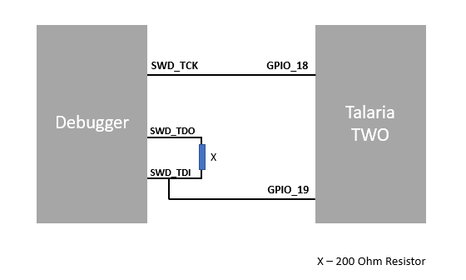

Figure : Hardware connections - SWD

For more information on GDB commands, refer: <https://sourceware.org/gdb/current/onlinedocs/gdb/>.

## Procedure to Debug using GDB through JTAG

This section provides details regarding debugging the application through JTAG. Make the connection between the debugger and Talaria TWO device as shown in Figure 11.

1. Open the SDK folder in Ubuntu terminal and type the following command to start OpenOCD:

|  |
| --- |
| openocd -s ./conf -f ftdi.cfg -f t2.cfg |

Console output:



Figure : Running OpenOCD for JTAG

1. In a separate terminal, run the following command from the apps directory. In this directory, there is a .gdbinit file that configures the GDB. Here, the RAM portion of the ELF gets loaded.

|  |
| --- |
| gdb-multiarch ../examples/using_wifi/out/wifi_connect.elf |

Console output:

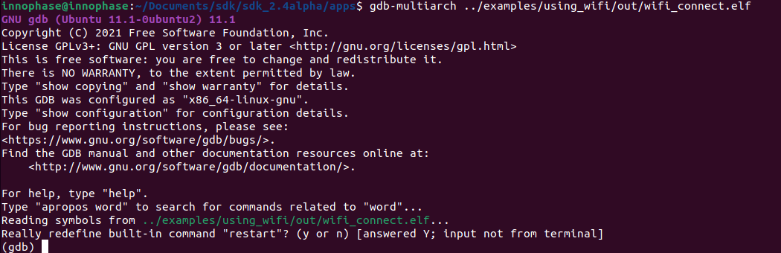

Figure : Running GDB for JTAG

Follow the procedure mentioned in section: *Start the GDB Session* to execute the GDB command.

## Procedure to Debug using GDB through SWD

This section provides details regarding debugging the application through SWD. Make the connection between the debugger and Talaria TWO device as shown in Figure 10.

1. Open the SDK folder in Ubuntu terminal and type the following command to start OpenOCD:

|  |
| --- |
| openocd -s ./conf -f ftdi_swd.cfg -f t2_swd.cfg |

Console output:

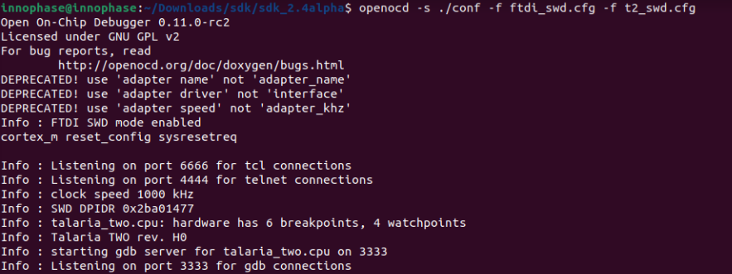

Figure : Running OpenOCD for JTAG

1. In a separate terminal, run the following command from the apps directory. In this directory, there is a .gdbinit file that configures the GDB. Here, the RAM portion of the ELF gets loaded.

|  |
| --- |
| gdb-multiarch ../examples/using_wifi/out/wifi_connect.elf |

Console output:



Figure : Running GDB for JTAG

1. Follow the procedure mentioned in section: *Start the GDB Session* to run the GDB commands.

# Procedure to Debug using GDB in Windows CMD

## Prerequisites

1. Windows PC
2. OpenOCD setup
3. GDB-Multiarch setup

## OpenOCD Setup

To install the environment for GDB debugging in Windows, follow the instructions described in sections: *Prerequisites for Eclipse* and *Add Paths to the Environment Variable* of the document: UG_Eclipse_Setup_Windows.docx (*sdk_x.y\doc\user_guides\ug_eclipse_setup_windows*).

## GDB-Multiarch

MSYS2 is a collection of tools and libraries, which provides an easy-to-use environment for building, installing and running in native Windows software. MSYS2 allows user to install GDB-Multiarch in windows machine.

Download the installer from the following link: <https://www.msys2.org/>.

Follow the installation procedure available in the above link. After completing the installation, click on Finish, which will create a popup for MSYS2 CMD line interface.

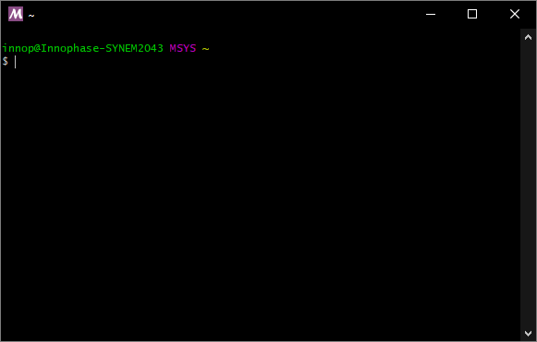

Figure : Running MSYS2

Run the following command in MSYS2 terminal and proceed with installation.

|  |
| --- |
| pacman -Syu |

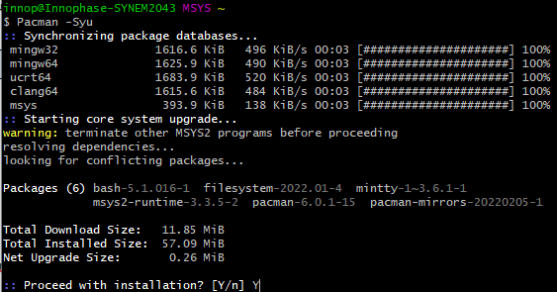

Figure : Installing mingw setup

Once the installation is complete, the window will be automatically closed. Run MSYS2 MSYS from the Start menu and run the following command in terminal to update the rest of the base packages.

Proceed with installation.

|  |
| --- |
| pacman -Syu |

After completing the installation, run the following command to install GDB-Multiarch:

|  |
| --- |
| pacman -S --needed base-devel mingw-w64-x86_64-toolchain |

Enter a selection number, for GDB-Multiarch as shown in figure.

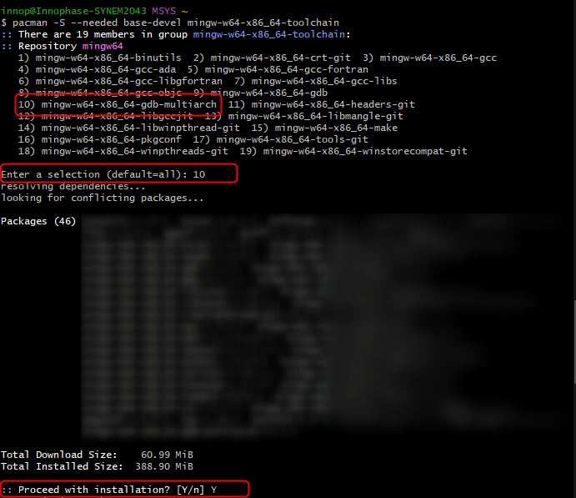

Figure : Iinstalling gdb-multiarch

Add MSYS2 path in environmental variable to access GDB-Multiarch in command line. To add path to environment variable, follow the steps mentioned in section: *Add Paths to the Environment Variable* of the document for MSYS2: UG_Eclipse_Setup_Windows.pdf ((*sdk_x.y\doc\user_guides\ug_eclipse_setup_windows*).

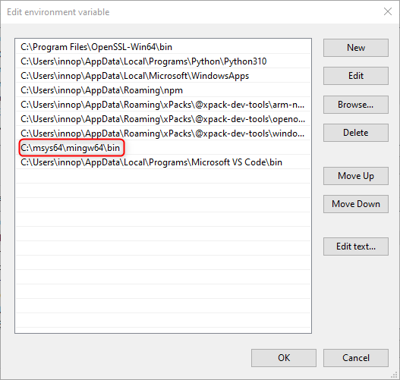

Figure : Adding environment variable

## Procedure to Debug using GDB

Following is the procedure to debug the VM-based applications using GDB:

1. Open the SDK folder in windows command line and type the following command to start OpenOCD:

|  |
| --- |
| openocd -s .\conf -f ftdi.cfg -f t2.cfg |

Console output:

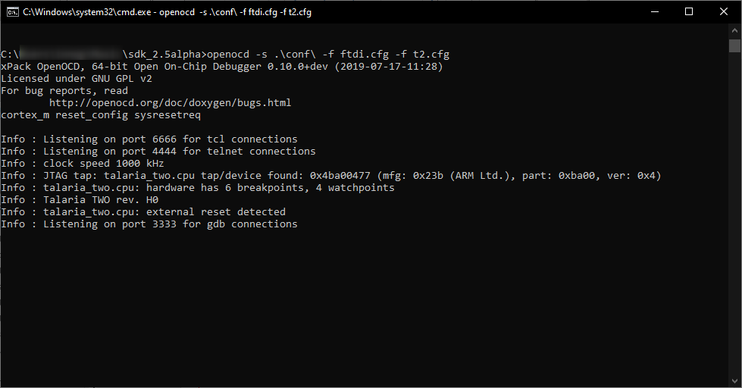

Figure : Running Openocd in windows CMD

1. Use the Download Tool to flash the virtual image from the SDK directory.

For example: Consider wifi_connect.elf.

**Note**: For the GDB to work, ELF needs to be loaded. By default, the SDK package contains ELF files in the bin folder (which are stripped ELF files). Hence, the user needs to build the sample application, generate the ELF file (by default, the ELF gets generated in the out folder) and load this ELF for debugging.

For building in windows, follow the steps described in section: *Building Application in Eclipse* of the document: UG_Eclipse_Setup_Windows.pdf ((*sdk_x.y\doc\user_guides\ug_eclipse_setup_windows*).

Execute the make for using_wifi example application (*sdk_x.y\examples\using_wifi*) to generate the ELFs under the out folder.

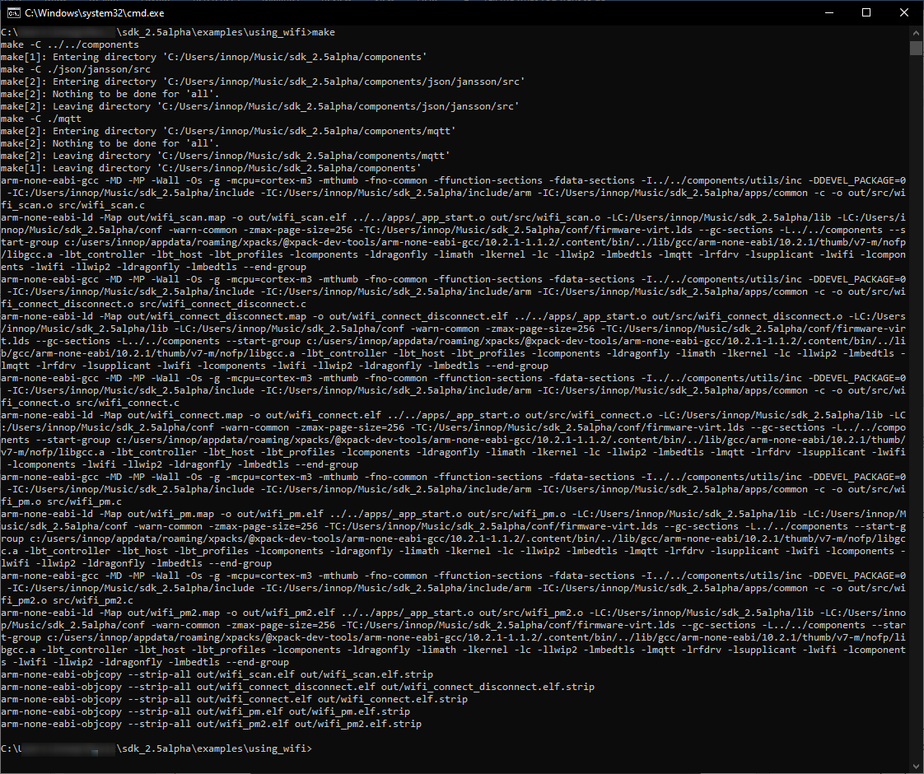

Figure : Running make command in windows CMD

.gdbinit initialization file contains the information on Talaria TWO’s memory and the required scripts of the GDB sources. gdbinit file is present under the *apps* folder. To start the GDB session, gdb-multiarch should be started from this folder.

Manual method of configuring the gdbinit file:

If there are any warnings as shown in Figure 6, the gdb-multiarch will not work for GDB commands. Hence, create a file named gdbinit in the home directory to allow auto-load.

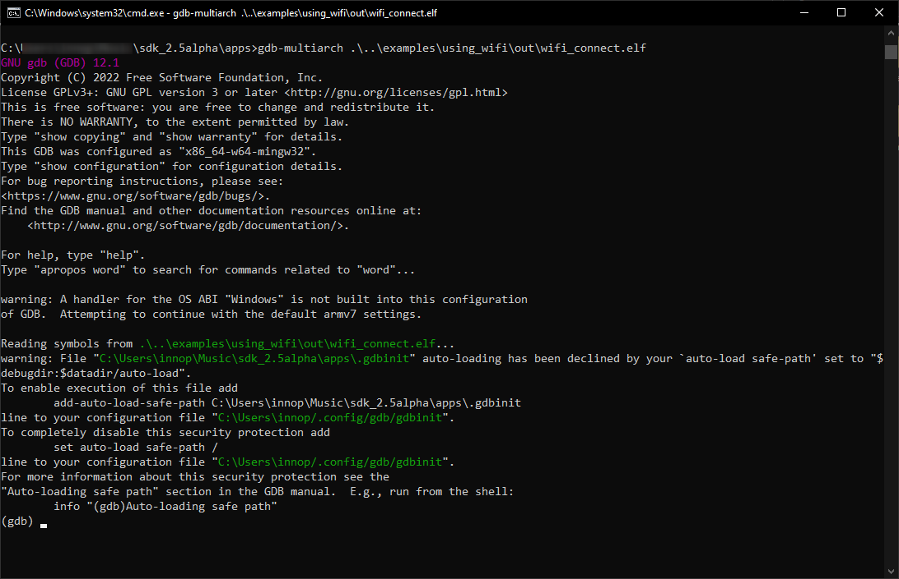

Figure : Warning for .gdbinit file

In the created gdbinit file, add the following path:

add-auto-load-safe-path C:\Users\innop\Music\sdk_2.5alpha\apps\.gdbinit

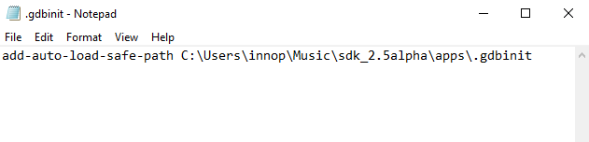

Figure : Configuring the gdbinit file

## Start a GDB session

In a separate terminal, run the following command from the *sdk_x.y\apps* folder. In this directory, there is a .gdbinit file that configures the GDB. Here, the RAM portion of the ELF gets loaded.

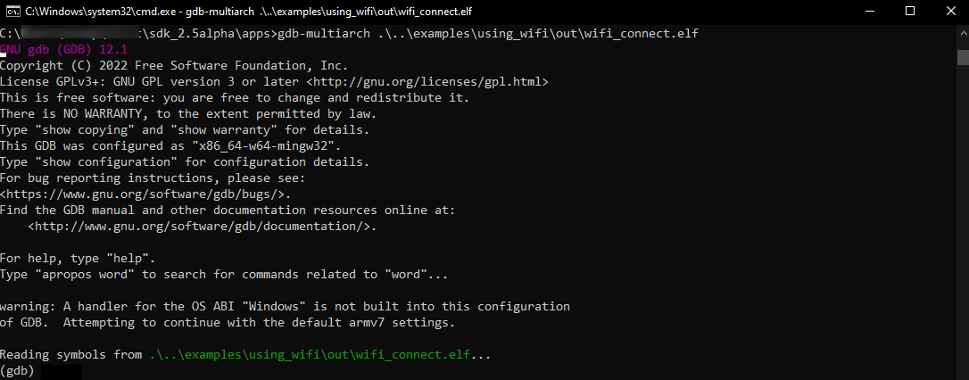

Figure Running GDB

1. Connect to OpenOCD by running ocd in the GDB prompt.

|  |
| --- |
| ocd |

1. Set a break point at main:

|  |
| --- |
| b main |

1. Run the application by executing:

|  |
| --- |
| R |

1. Information on the break points set can be seen by issuing:

|  |
| --- |
| info b |

1. A break point at a line number of a particular source file can be set using:

|  |
| --- |
| b <filename>: <linenum> |

1. If the line to be executed is a function call, GDB will step into that function and start executing its code one line at a time.

|  |
| --- |
| s |

1. If the entire function needs to be executed with one key press, type next or n.

|  |
| --- |
| next |

1. Continue running the program (after stopping, for example at a breakpoint).

|  |
| --- |
| continue |

1. Step out is the operation that resumes execution after the function the program is executing terminates. The debugger will stop at the statement after the function call.

|  |
| --- |
| finish |

Example 1: Following is the output while debugging the wifi_connect.elf using GDB:

|  |
| --- |
| (gdb) ocd  warning: A handler for the OS ABI "Windows" is not built into this configuration  of GDB. Attempting to continue with the default armv7 settings.  0x00023f36 in ?? ()  (gdb) b main  Breakpoint 1 at 0x150e04: file src/wifi_connect.c, line 79.  Note: automatically using hardware breakpoints for read-only addresses.  (gdb) R  JTAG tap: talaria_two.cpu tap/device found: 0x4ba00477 (mfg: 0x23b (ARM Ltd.), part: 0xba00, ver: 0x4)  target halted due to debug-request, current mode: Thread  xPSR: 0x01000000 pc: 0x00020f90 msp: 0x00041a78  Loading section .text, size 0x13778 lma 0x42000  Loading section .data, size 0x520 lma 0x55778  Loading section .virt0, size 0x10a28 lma 0x2000000  Loading section .virt1, size 0x17c98 lma 0x3000000  Loading section .virt2, size 0x22824 lma 0x4000000  Loading section .virt3, size 0x628 lma 0x5000000  Loading section .virt4, size 0x5704 lma 0x6000000  Loading section .virt5, size 0x2ec lma 0x7000000  Start address 0x00047d00, load size 412564  Transfer rate: 71 KB/sec, 13308 bytes/write.  Program received signal SIGTRAP, Trace/breakpoint trap.  shutdown () at arm/entry.S:196  196 arm/entry.S: No such file or directory.  (gdb) info b  Num Type Disp Enb Address What  1 breakpoint keep y 0x00150e04 in main at src/wifi_connect.c:79  (gdb) del 1  (gdb) info b  No breakpoints or watchpoints.  (gdb) b main.c:29  Breakpoint 2 at 0x112704: file core/main.c, line 30.  (gdb) R  JTAG tap: talaria_two.cpu tap/device found: 0x4ba00477 (mfg: 0x23b (ARM Ltd.), part: 0xba00, ver: 0x4)  target halted due to debug-request, current mode: Thread  xPSR: 0x01000000 pc: 0x00020f90 msp: 0x00041a78  Loading section .text, size 0x13778 lma 0x42000  Loading section .data, size 0x520 lma 0x55778  Loading section .virt0, size 0x10a28 lma 0x2000000  Loading section .virt1, size 0x17c98 lma 0x3000000  Loading section .virt2, size 0x22824 lma 0x4000000  Loading section .virt3, size 0x628 lma 0x5000000  Loading section .virt4, size 0x5704 lma 0x6000000  Loading section .virt5, size 0x2ec lma 0x7000000  Start address 0x00047d00, load size 412564  Transfer rate: 71 KB/sec, 13308 bytes/write.  Program received signal SIGTRAP, Trace/breakpoint trap.  shutdown () at arm/entry.S:196  196 in arm/entry.S  (gdb) |